# Overview

The CBUS protocol provides commands to allow the configuration of a module by a networked computer. These commands allow the read & write functionality of numbered variables, but doesn’t describe what those variables do – as this is different across different modules

Thus, modifying a computer program to allow users to configure new modules has been a very time-consuming process, and typically not possible by the module developer

This document aims to provide a way to describe what these variables mean, in a form that can be digested by a computer program to provide a meaningful user interface, without changing the software programming, thus available to all module developers

This is intended to describe what the module variables mean, not dictate how the user interface is implemented. However, pragmatically some things are best described in user interface terms

# General

CBUS Modules are identified by manufacturer/model numbers, which are stored in the firmware. So the module actually refers to the firmware, and not the physical board the firmware resides on, although most of the firmware has been written for a specific type of board. There is, however, some firmware that will run on different hardware, and will report the same module identification irrespective of which hardware they are running on. Equally, there is specific hardware that have had different variants of firmware written for them, so such hardware will report a different module ID depending which variant of firmware is loaded

In this file the module is described using key-value pairs, the key identifies the data, and the value is the data content, which can be various types of literal (fixed) data, such as string, numeric or an array to ‘nest’ further key-value pairs

Key-value pairs can be represented in many data formats, with JSON being the preferred format widely supported by many languages

Camel case is the preferred naming format for keys, unless specified otherwise

Camel case is the practice of starting each word with a capital letter, except for the first word.

There is no direct support for comments, but a key-value pair can be used where necessary

E.g. “comment”:”comment added for clarity”

# File naming convention

The filename is generated from the module name, the manufacturer/module identification and the firmware version. Leading with the module name makes the files a little easier to sort by eye

Kebab case formatting (- sign separator) is used to separate the 3 items

Note the firmware version is kept in the same format as used in firmware documentation, i.e. number followed by character

AAAAAAA-BBCC-DE

Where

**AAAAAAA** : variable length module name registered against the manufacturer ID & Module ID

**BB** : Manufacturer ID in hexadecimal - two hex digits

**CC** : Module ID in hexadecimal - two hex digits

**D** : Firmware major version in decimal - 1 to 3 digits

**E** : Firmware minor version in single ascii character

Example:

CANACC4-A501-2q.json

# top-level section

## moduleDescriptorName

This property is the filename described above without the extension. This is an important property that is used to identify the descriptor when the content of the file is being as a data object programmatically (i.e. not as a file with a filename)

## moduleName

This optional property in the root section is the name registered against the manufacturer ID & Module ID for this specific module. The value returned from the CBUS command NAME is typically a subset of this module name due to data restrictions

## NVsetNeedsLearnMode

One family of firmware based on original CANSERVO8 code needs to be put into ‘learn’ mode before node variables can be programmed. Setting the NVsetNeedsLearnMode key to a value of true in the root section will indicate if this is required for this specific module. The processing application is expected to assume false if this property is not present, so it’s only required if set to true

# nodeVariables & eventVariables sections

These sections are the descriptors for node & event variables. Both of these have types and properties that work in the same way.

The major difference between the two is that there is only one instance of the node variables for each module, where there can be multiple instances of the event variables, so the actual types reflect that difference, but share the same properties

A group type element is defined to allow the grouping of elements using an array

For many modules, the meaning of certain variables change depending on the value of another variable. To cater for this, a visibilityLogic property has been created. This allows more than one descriptor for a single variable to be created, but controls which of these descriptors actually gets displayed by the result ‘visibilityLogic’ element (only display is logic returns true), this should be supported on all types

Another option is Overloaded Labels, which allows different labels to be presented depending on another variable, all within a single descriptor. Note this is only available on certain types

## Types

The type property indicates what the variable represents and how should be handled

Note not all types duplicated for both, as created on an ‘as needed’ basis

|  |  |
| --- | --- |
| EventVariableBitArray  NodeVariableBitArray | Represents an 8 bit node variable where each bit can be selected independently - also known as flags, bitfield or multi-select  Uses bitCollection to define the bits & their labels  Uses displayTitle, displaySubTitle  Supports Overloaded labels |
| EventVariableBitSingle  NodeVariableBitSingle | Represent a single bit in a node variable  Uses the bitPosition property to identify which bit  Uses displayTitle, displaySubTitle |
| NodeVariableDual | Represents a two byte variable as a simple numeric input value  Uses displayTitle, displaySubTitle |
| EventVariableGroup  NodeVariableGroup | Allows a collection of types to be logically grouped together, differs from Tabs in that multiple groups can be visible at the same time, and expected to have less content  Uses the groupItems property, which can contain any of the other types including the ‘Tabs’ types  Doesn’t use any other properties |
| EventVariableNumber  NodeVariableNumber | Represents a variable as a simple numeric input value  Option to use min & max to limit user input  Option to use startBit & endBit to use a subset of the bits in a variable  Option to use displayOffset to adjust displayed values  Uses displayTitle, displaySubTitle  Doesn’t use displayScale or displayUnits |
| EventVariableSlider  NodeVariableSlider | Represents a variable as a slider control  Option to use description to show more information  Option to use displayScale, displayUnits and displayOffset to adjust displayed values  Uses displayTitle, displaySubTitle  Option to use min & max to limit user input  Option to use startBit & endBit to use a subset of the bits in a variable  NodeVariableSlider supports the option to use outputOnWrite to show output is set immediately on a write (can implement a ‘test’ feature) |
| EventVariableSelect  NodeVariableSelect | Represents a control to select a single value from the array of options  Option to use bitMask to define a subset of the bits to use  Option to use displayScale to adjust displayed values  Option to use displayUnits to display units of measure  Uses displayTitle, displaySubTitle  Supports Overloaded labels |
| EventVariableTabs  NodeVariableTabs | Defines the logical grouping of a set of variables, differs from ‘groups’ in that only the contents of one tab (tabPanel) is visible at a time, typically the full width of the display area, and would typically have more content than a group  Uses the tabPanels property to define a set of tabs and the content of the associated tab panels, the content is any of the other types including the ‘group’ types.  Doesn’t use any other properties |

## Properties for nodeVariable & eventVariable

|  |  |  |  |
| --- | --- | --- | --- |
| **property (key)** | **type** | **requirement** | **default** |
| type | string | mandatory | Not Applicable |
| nodeVariableIndex  eventVariableIndex | numeric | mandatory | Not Applicable |
| bitPosition | numeric | Mandatory for some types | Not Applicable |
| bitCollection | array | Mandatory for some types | Not Applicable |
| bitMask | numeric | optional | 255 |
| min | numeric | optional | 0 |
| max | numeric | optional | maximum size of the variable type |
| startBit | numeric | optional | 0 |
| endBit | numeric | optional | 8 |
| groupItems | array | Mandatory for some types | Not Applicable |
| displayTitle | string | Mandatory for some types | Not Applicable |
| displaySubTitle | string | optional | Not Applicable |
| displayScale | numeric | optional | 1 |
| displayUnits | string | optional | blank |
| displayOffset | numeric | optional | 0 |
| options | array | optional | Not Applicable |
| outputOnWrite | boolean | optional | false |
| tabPanels | array | Mandatory for some types | Not Applicable |
| visibilityLogic | Logic  element | optional | Not Applicable |

## bitCollection

An array of bitPositions and associated labels used to define a collection of a variable number of bits and their labels used in the BitArray types. bitPositions start from 0

Each array entry of the form {“bitPosition”: 1, "label": "bit description"}

## bitMask

A bit value of 1 in the bitMask indicates that the corresponding bit position in the variable should be modified, a value of 0 shows the corresponding bit position in the variable should keep its original value. This allows a type to modify just part of a variable, and leave the remainder for another type to modify. See options description for an example of how it can be used

## min/max

This pair usually relates to the raw value in the node variable, not the display value, unless stated otherwise in the type description above

## startBit/endBit

Describes the starting and ending bits of a value that doesn’t use all 8 bits of a variable. Typically used to create a bit mask to use to ensure that unused bits are not modified when this value is updated

## displayScale & displayUnits

For numeric values, this pair allows the variable to be displayed in a ‘friendly’ fashion, e.g. a time delay in 100mS intervals would have a displayScaling of 100 and a displayUnits of ‘mS’

These do not affect the underlying ‘raw’ variable

## displayOffset

Used in special circumstances where the value the variable represents doesn’t start at 0. E.g. a time delay may have a minimum of 500mS (i.e. the variable value of 0 represents 500mS), but intervals of 100mS could have a display offset of 500. Another example would be to use an offset of 1 to display channel numbers 1 to 8, that’s stored in 3 bits which have a range of 0 to 7.

Can also be used to display negative starting values, whilst keeping the raw value unsigned, e.g. using an offset of -100 to display -100 to +100 with the raw value in the variable being 0 to 200 - however, probably less useful in this application

## displayTitle

The main description of the item

## displaySubTitle

An optional element that can be used to add further information about the item - e.g. “Range 50 to 25500 mS”

## groupItems

An array used by the NodeVariableGroup type to logically group other types together, e.g. to group more than one node variable to a single channel

## options

Array of labels with values to be used in the NodeVariableSelect type.

Each array entry of the form {"label": "Options 1", "value": 0}

The value field maps onto the bits in the variable, for example, if the top 2 bits are used (bits 6 & 7), then the array will take the form

{"label": "event sent at ON end", "value": 0}, – bits 6 & 7 clear

{"label": "event sent when at OFF end", "value": 64}, – bit 6 set, 7 clear

{"label": "event sent at mid travel", "value": 128}, – bit 6 clear, bit 7 set

{"label": "Start of Day (SoD) event", "value": 192} – bits 6 & 7 set

The bitMask option can be used to limit modifications to the specific bits, in this case a value of 192 would be used (bits 6 & 7 set to only allow those to be modified)

## outputOnWrite

If true, this indicates that when this variable is written to, the associated output immediately takes on this new value.

In some modules this is seen in the servo position variables, and has been used to provide a ‘test’ feature by re-writing the current variable value, e.g. to move the servo to the ‘on’ position

Currently only supported in the NodeVariableSlider type.

## tabPanels

An array used by the NodeVariableTabs & EventVariableTabs types to logically group other types together in tabbed panels

Each entry in the array contains the displayTitle of the tab, and a further array of items that form the content of the tab panel

{ "displayTitle": "Tab number one",

"items": [

{

"type": "EventVariableNumber",

"eventVariableIndex": 1,

"displayTitle": "Output 1-1"

}

]

}

## visibilityLogic

This optional property uses a logic element (see below for more detail) to only display the descriptor if the logic returns true.

This is typically used where the meaning of a variable changes depending on another variable - e.g. on some modules, event variables change meaning (or not used) if the event is marked as a ‘produced’ event, or ‘consumed’ event

Having this “visibilityLogic” property allows multiple descriptors to be defined for the same variable, but then select which one gets displayed depending on the result of the logic element

# 

# Overloaded labels

In more complex modules, the same variable has different meaning depending on another variable - an example being the following partial extract for a configuration for EV#1

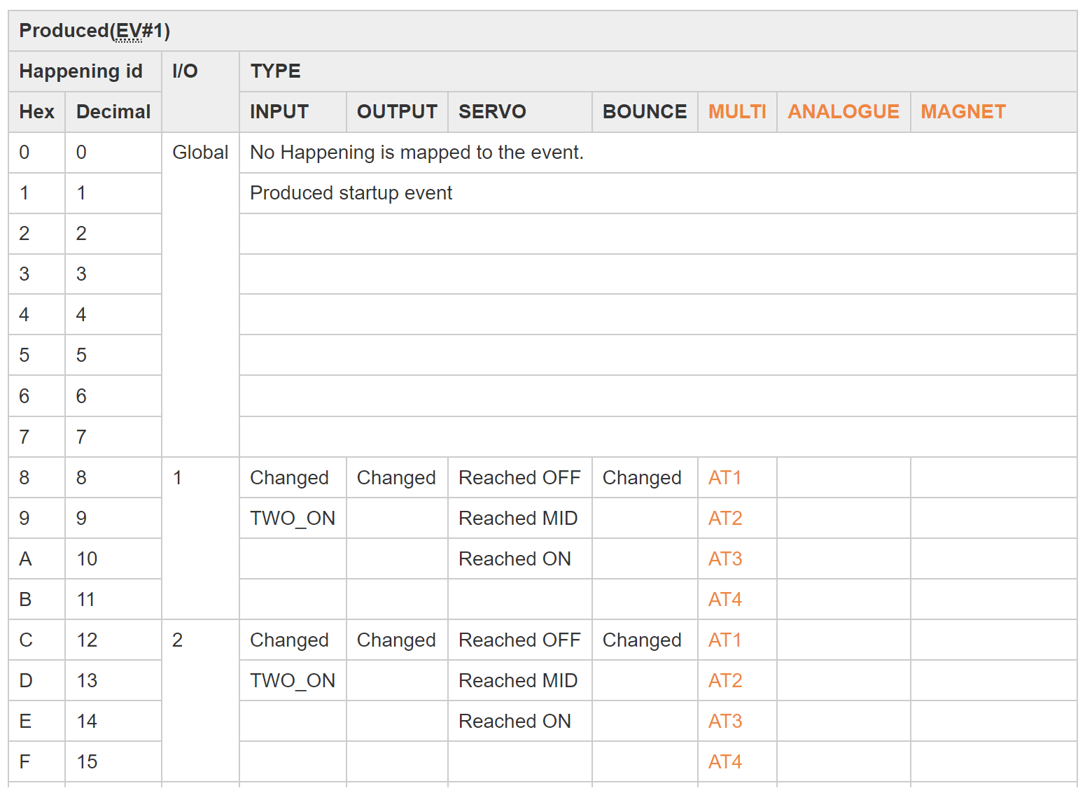

Where the variable is an encoding (i.e. each value has a different meaning), then only the label needs to be changed to describe a different meaning for that value

This isn’t suitable for variables that aren’t encodings, hence only certain types support it

The following element describes how to ‘overload’ the label in types that support it

“overload”{“nv”,labels[“value”:0, “label”: “first label”, “value”:1, “label”: “2nd label”,.....]

For example, the following shows how the table above is represented

{

"type": "EventVariableSelect",

"eventVariableIndex": 1,

"displayTitle": "Produced event",

"displaySubTitle": "EV1",

"options": [

{"value": 0, "label": "no event (0)"},

{"value": 1, "label": "Startup event (1)"},

{"value": 8, "overload":{"nv": "16", "labels": [

{"value": 0, "label": "CH1 - Input Changed"},

{"value": 1, "label": "CH1 - Input Changed"},

{"value": 2, "label": "CH1 - Reached OFF"},

{"value": 3, "label": "CH1 - Input Changed"},

{"value": 4, "label": "CH1 - AT1"}

]

}

},

{"value": 9, "overload":{"nv": "16", "labels": [

{"value": 0, "label": "CH1 - TWO_ON"},

{"value": 2, "label": "CH1 - Reached MID"},

{"value": 4, "label": "CH1 - AT2"}

]

}

},

…

# Logic elements

A logic element allows simple logic to be embedded into the descriptor

The logic returns a true or false condition for the named property, and can be used for more than one named property

The logic follows the syntax

“Named Property”:{ “argument”, “condition”}

The intent is that the “argument” always evaluates to a simple numeric value, and the condition just needs to compare two simple values

For example, in the following property, “visibilityLogic”, the result of the logic element is used to control if a variable is displayed or not

And in this case, the variable would only be displayed if the value of ev3 bit 7 is equal to 1

"visibilityLogic":{

"evBit": {“index”:3, “bit”: 7}

"equals": 1

},

## Logic conditions

|  |  |
| --- | --- |
| **condition** | **description** |
| “equals”:<value> | Equal to, with numerical value, will return true or false |
| “in”:[<value>,...] | Equal to any value in the array, will return true or false |

## Logic arguments

|  |  |
| --- | --- |
| **item** | **description** |
| “evBit”: {  “index”:<ev index>,  “bit”: <0 to 7>  } | Describes a single event variable bit with numerical values for event index and bit position (0 to 7). Will evaluate to 0 or 1 |
| “nv”:<nv index> | Describes a node variable by it’s index number, will evaluate to a number 0 to 255 |